What is the complexity analysis of Binary Search?

1. O(1)
2. O(n)
3. O(log n)
4. O(n2)

What is output of the following code?

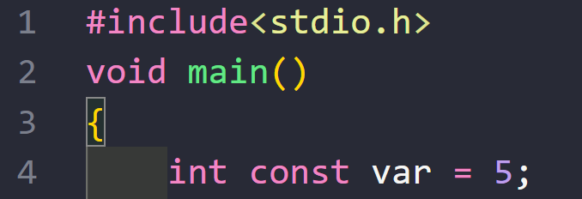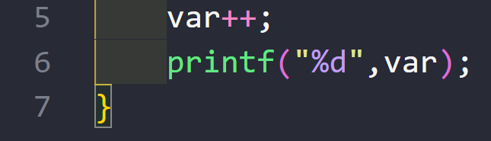

1. 5
2. 6
3. Error
4. None of these

What is output of the following code?

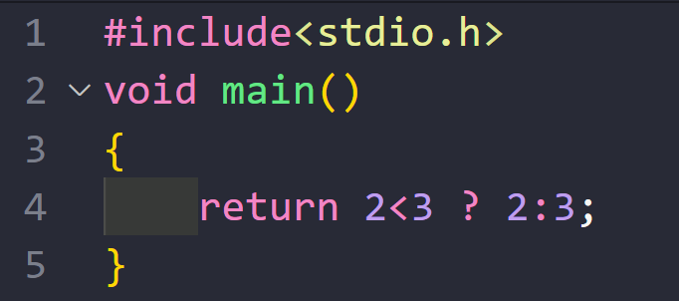

1. 2
2. 3
3. 2 3
4. Error

What is the output of the code?

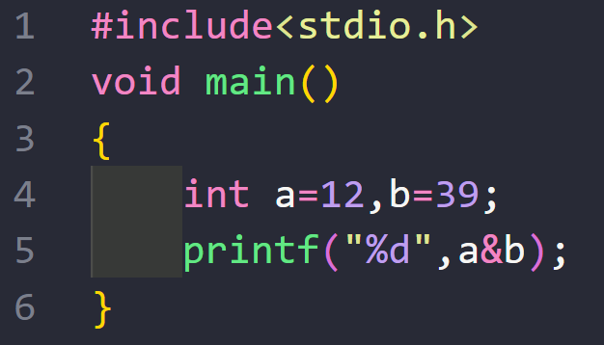

1. 468
2. 1
3. 4
4. Error

Fill in the blank to get the following output?

Output: 8, 114

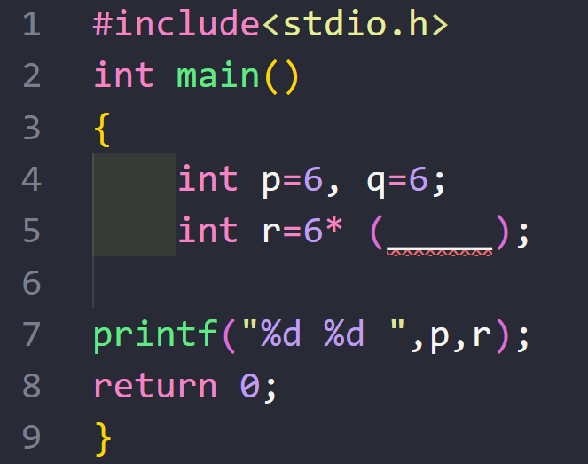

1. (p + q + p++)
2. (p++ + q + p)
3. (p++ + q + p++)
4. None of these

What is output of the following code?

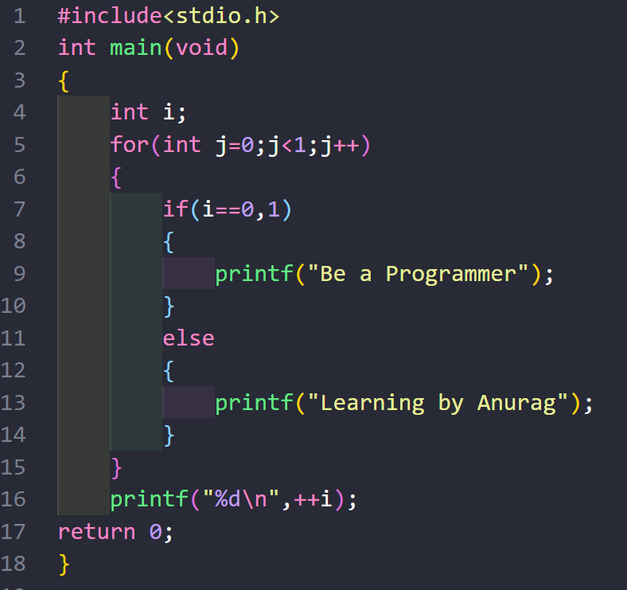

1. Be a Programmer 1
2. Learning by Anurag 0
3. Learning by Anurag 1
4. None of these

What is the output of the code?

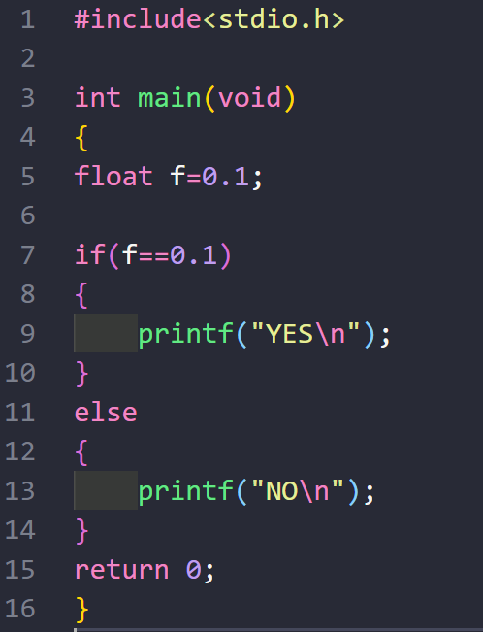

1. YES
2. NO
3. None of These

What is the output of the following code?

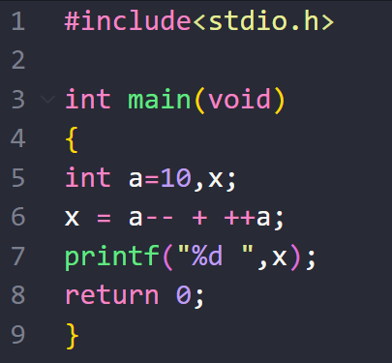

1. 19
2. 20
3. 22
4. 23

Pre-Order traversal of the tree is-:

17, 13, 9, 11, 15, 19, 23, 21

What will be the post order traversal?

1. 23, 21, 19, 17, 15, 13, 11, 9
2. 9, 11, 13, 15, 23, 21, 19, 17
3. 11, 9, 15, 19, 19, 21, 23, 17
4. 11, 9, 15, 13, 21, 23, 19, 17

Consider the following array, 55, 40, 45, 48, 10, 46, 15

Transform this into a max heap

Arun wants to implement and image viewer application to view images in a given folder. The application will be able to display an image and will also know what its next and previous images are at the given point of time so that the user can so that the user can view next/previous image by pressing right/left keys on the keyboard. Which data structure is appropriate for Arun to use?

1. Tree
2. Queue
3. Linked Lists
4. Stack

Arun is developing a word processing software in which she wants to provide undo feature the software will maintain all the sequential changes and at any point of time pressing control z will undo the latest change, which data structure is appropriate for Arun to use?

1. Array
2. Queue
3. Linked Lists
4. Stack

Arun is developing an IP telephony software in which the audio is encoded and transmitted by the sender as network packets though a communication channel. At the other end these packets are assembled and processed further. Esha recognizes that there may be a very large number of packets this number is unknown and which will be processed while more packets are being received assume that packets arrive in right order, which data structure is appropriate for Arun to use?

1. Array
2. Queue
3. Linked Lists
4. Stack

B